**Wind Energy Design Project**

**Task 2**

Cameron Earl, Jeremy Johnson

Jerry Craig, Matt Dew

ECE103 – Engineering Design and Modeling

**1. Introduction**

The Purpose of Task 2 in the Wind Turbine design project was to determine an appropriate Airfoil shape along with all of the relevant characteristics and then be able to explain the reasons for our design choices of the final blade design. We choose to start our design based on data obtained from a working popular wind turbine in the 600 kW rated range. We choose a Free Breeze PS600 which is a rebranded Vestas V47-PS600 model to base our calculations on (free breeze). The turbine has a 600kW power output and is a popular selection for rural locales for power generation. As per handout #1, a 600 kW generator will produce enough power for approximately 200 homes.

Consideration was given to the appropriate number of blades for the turbine and the optimum chord length based on a 23.5m diameter. From the optimum chord length we generated an appropriate Reynolds number to use for the calculations and then tested that number against various other parameters to make sure we had picked an appropriate final design. The project also focused on further expanding our knowledge and use of various engineering software analysis tools to help us to make sure that we were picking the right design, or at least to explain the reason behind our choice of design.

**2. Methods and Data**

To begin the process we determined to base our model on a 3-bladed wind turbine system. According to the Wind Vision (US Department of Energy) report just released by the Department of Energy, they are the most popular and thus have the most available research into optimizing the design. The next task was to determine a size range that we wanted to optimize the wind turbine for. We chose a smaller 600kW version in order to stay with our altruistic theme since this size is more popular in remote areas. One of the popular 600kW turbines is the Free Breeze 600 which has a 47m rotor diameter and a 23.5m radius (free breeze). Once the radius was determined we used a formula based on the Betz limit to determine the optimal chord length for the blades. The optimal chord length formula found in a paper from Peter J. Schubel and Richard J. Crossley references several different possible formulas that can be used to derive the optimal chord length but suggests that the formula in Figure 1 is adequate for most circumstances (Schubel and Crossley 3431,3432). Based on this formula with a radius of 23.5m, 3 blades, 1.5 Coefficient of Lift, 12 m/s design wind speed, 6 for ratio and 72.993 for the resultant wind speed, the optimal chord length (at the widest point) was calculated to be 0.800m.

**Figure 1: Formula for optimal chord length**

Once the chord length was determined, we were able to generate realistic Reynolds numbers based on the formula of $Re= \frac{ρVL}{μ}$ where $ρ$ = the density of the fluid which we used 1.19 Kg/m3, V is resultant wind speed (same as Vr above) at 72.993, L is the linear dimension which is the need for chord length and set to 0.800m and all divided by $μ$ =18.27e-6 from the handout for the density of air and the viscosity of air. The Reynolds number that we used in our calculations was 3,799,453.

Once the local Reynolds number was generated we were able to use Xfoil to evaluate several different optimum chord lengths and Coefficient of Lift values to better narrow down the 0.800m chord length from the above formula and verify our design parameters were in line with expectations. The analysis of figures 2 and 3 of the final Xfoil data reflecting our final design indicates that at an alpha or angle of attack near to 15° would result in a good Coefficient of Lift while reducing the drag as well. At 17 degrees the blade enters into a stall so we determined to use a 15 degree angle of attack to allow for wind gusts and sudden changes of wind direction. This also most closely resembled the Cl used for calculating the optimum chord length.



Figure 3

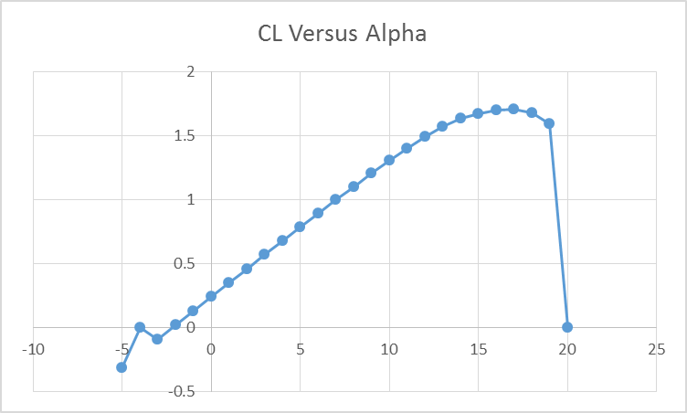

Figure 2

Our analysis of the blade design for the wind turbine next examined the chord profile across the length of the blade utilizing the formulas in Figure 4. These formulas produce the Reynolds number, twist angle and chord length along the blade at specific r values from between 0 and 23.5m. The resulting Figure 5 details the cross section plot at the various intervals along the entrire span of the blade from 0 to 23.5m.

**Figure 4:** Formulas to calculate chord profile along blade

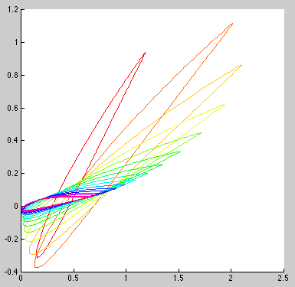**Figure 5:** Blade cross sections from base to tip at 16 equally spaced intervals from 1m to 23.5m. Cross sections nearest base are most vertical.

**3. Conclusion**

While there was plenty of data relating to the rotor diameter of the various wind turbine offerings that are currently available, the specific dimensions, especially the chord length, appear to be a closely guarded secret. We were able to take the data that was provided, derive that which was not provided, and graphically analize a working blade design for a wind turbine generator within the constraints of a 12m/s wind-speed design. It was interesting that the Chordr formula closely resembled the Betz formula that was used to determine the optimum chord length, lending validity to both of those calculations and helping to explain where and how the formulas were derived. We were also able to use Xfoil to narrow the analize the Coefficient of Lift and Drag on the wing which helped us to determine the best angle of attack and the right Coefficient of Lift to use for the final plot of the 16 sections of the blade in Figure 5. Figure 5 is the culmination of this project by taking the Matlab code from the last project, adding a modified chord length and rotational element to the plot and then optimizing our blade design as relates to Reynolds number, twist and chord length. We are now prepared to look at the nacelle and further expand the project to the final design phase.

# 4. References

Free breeze. *Free breeze energy systems ltd.* n.d. web. 2015 1 4. <http://www.freebreeze.com/wind-turbines/ps600-600kw-wind-turbine.html>.

Schubel, Peter J and Richard J Crossley. *Wind Turbine Blade Design*. Engineering Energy Report. Nottingham: MDPI Open Access, 2012. Wind Turbine - energies edition. 4 2015. <http://www.mdpi.com/search?q=&journal=energies&volume=&authors=schubel&section=&issue=&article_type=&special_issue=&page=&search=Search>.

US Department of Energy. *Wind Vision: A New Era for Wind Power in the United States*. Oak Ridge, TN 37831: United States, 2015. web pdf. 30 March 2015. <http://energy.gov/sites/prod/files/WindVision_Report_final.pdf>.